Version control system

TruePartner

By: Simeon Markov
Institution: Fontys UAS
Course: IN-SDE4
Date: 2026-04-01

Introduction
This document presents my GIT approach, managing version control system for both my codebase as well as documentation history.

GIT management
For this project, GIT Flow strategy was used. It has the following branches: main (production), dev, feature (testing) & release.
Management platform for GIT: For this project, GitLab was used. The repository is set to public, accessible by everyone within GitLab Fontys organization.
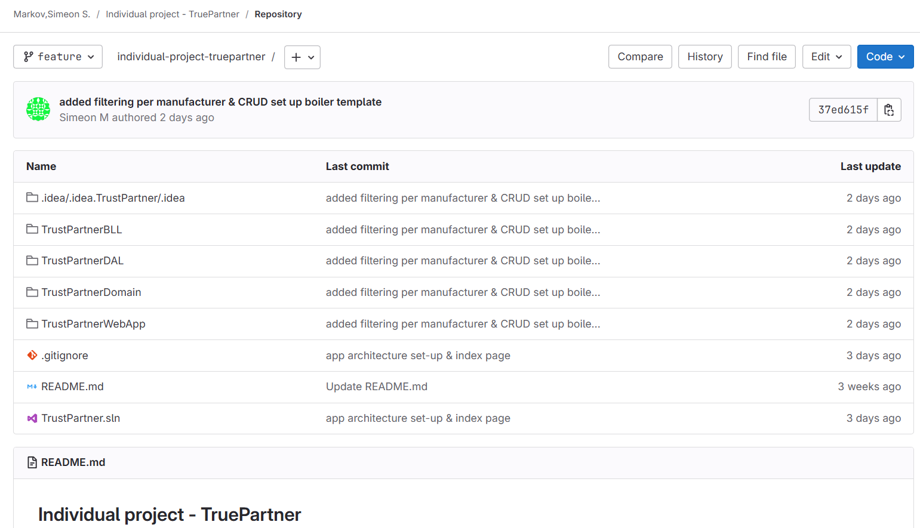
Example snippet of GitLab commit history:
Figure 1: Snippet from feature branch
Note: In the feature branch serves as a testing & implementing different features before merging them with the develop branch

